John Tansill

The Rapid Urbanization of Georgia’s Coast
In the past decade there has been an increasing urbanization effort along the Georgia coast, particularly in the city of Savannah, and the Port of Savannah which is the fastest growing container port in the United States and third largest overall behind Los Angeles/Long Beach and New York/New Jersey (Donahue 2025). In addition to the success and growth of the port, the opening of a new Hyundai plant just northwest of Savannah added more jobs and manufacturing to the region. However, this economic and commercial growth has come at the expense of the environment, particularly forests and wetlands around the coast as much needed urban development has had to spread further out from the center of Savannah. Previous geospatial analysis studies have investigated the impact of urban development, and specifically expansion of the ever-growing Port of Savannah, and have shown that the already fragile coastal ecosystem in Georgia has been further jeopardized by poor environmental practices including manufacturing plant pollution, chemical intensive farming applications, and hazardous waste sites (Merem and Twumasi 2008). The 2008 study provides good context for the fragileness and predisposition of the coast as urbanization and manufacturing has only increased since then. To further explore the negative effects of urbanization on the coastal environment, this study attempts to analyze how urban development and urban sprawl can lead to the destruction of critical natural resources and wildlife habitats in the State of Georgia. My hypothesis is that along with increased population growth in the region, the need for urban expansion will create significant loss of natural resources in forests, wetlands, and agricultural lands along the Georgia Coast.
Data & Methods:
To best understand the environment in Coastal Georgia as it relates to urban expansion, data was drawn from a variety of sources. The first part of the analysis was to determine and map out the study area. This analysis focuses on the Southeastern Coastal counties of: Effingham, Chatham, Bryan, Liberty, McIntosh, Glynn, and Camden. A shapefile for the state of Georgia provided by the US Census Bureau Tiger Shapefiles program was loaded into ArcGIS Pro and filtered to the counties determined for the study area and exported as a new layer. The next part of the process involved downloading the Annual National Land Cover Database Collection 1.1 from the USGS EarthExplorer website. To understand how change has happened over the last decade, images were used from the 2014 and 2024 releases. These two images were loaded into ArcGIS and clipped to the bounds of the coastal counties study area. The two rasters were then projected to the native projection used for NLCD datasets which is Albers Equal Area Conic or EPSG:5070. Next, the Combine geoprocessing tool was used to compare the two images and would detect where changes had occurred. This tool produced a new single raster image that contained an attribute table with information regarding the value, or the NLCD classification number, for both the 2014 and 2024 images. A new field was created using the field calculator tool to combine the two number (“’No Change if (!nlcd2014! == !nlcd2024!) else str(!nlcd2014! + ‘-‘ + !nlcd2024!). This created a new field where pixels that didn’t change stated “No Change” and pixels that did listed the type of change (eg. “11-24”). At this point a duplicate of the combined raster was created to preserve the data of the original, and filtered to only include pixels where numbers 41-43, 81,82, and 90,95 changed to numbers 20-24, or where agriculture, forests, and wetlands, had changed to developed land from 2014 to 2024. This new layer was then converted into polygons using the Raster to Polygon geoprocessing tool. New fields titled “Area Square Miles” and “Acres” were created and using the Calculate Geometry tool the area was calculated for each polygon. The final part of this phase in the analysis was to use the Intersect geoprocessing tool to identify where change was happening in relation to the counties of the study area. Once this tool was utilized a new square mile and acres field were created to determine the total land area of change type in each county respectively.
The second phase of the analysis was to use Google Earth Engine to load and create composite images for the months of May-September for the years 2014 and 2024 using Landsat-8 Satellite imagery. After defining the same study area with the Tiger 2018 Counties dataset boundaries, the summer season composites were created, and cloud masking was applied. After the median composites were created a Natural Difference Vegetation Index (NDVI) was calculated along with a difference calculation by subtracting the 2014 from the 2024 NDVI calculations. These three images were then exported and loaded into ArcGIS Pro for further analysis and visualization.
The last stage of analysis was to take the exported tables of the changed polygons for forests, wetlands, and agricultural lands into three separate excel spreadsheets where they were cleaned up and given names for each change type. They were then exported and opened up in Google Colab to use python to further summarize and understand the statistics of change. First the three csv files were read using the Pandas library to convert them into Data Frames. Then the three Data Frames were combined into one and given a new field name called “change source”. They were then sorted and grouped into categories by change detection from forest, wetlands, or agriculture. The last part, after reading and confirming the statistics were correct, was to create bar charts using the Matplotlib Library to provide a better overview of the data distribution by change type. Charts were created to show the broader overall trend of forest, wetland, and agricultural land loss to development, and a more specific one showing the distribution of each specific class lost to development.
Results:
The findings of this analysis were quite clear regarding the original hypothesis that the increasing urbanization of the Georgia coast, particularly in the Savannah area, has significantly impacted the local ecosystem and environment. In total there were just over 25,000 acres of combined forest, wetlands, and agricultural land lost to development between 2014 and 2024 across the Coastal Georgia study area. When breaking it down further, there was a notable loss to forests, particularly ‘Evergreen Forest’ as classified by the NLCD, which saw a total loss of approximately 17,128 acres of land over the entire study area (figure 2.1). The most prominent loss occurred just west of Savannah in Chatham County which saw the most loss of any county at 9,843 acres of forest loss alone. Although less impacted than forests, wetlands and agricultural land both saw total losses of 5,459 and 2,398 acres respectively. To further test the validity of the Land Cover change process, two composite images derived from Landsat-8 Satellite Imagery were created featuring images from May-September of both 2014 and 2024 to capture the peak green vegetation for both years. Calculating NDVI values for both years showed significant change in green or healthy vegetation in the outskirts of both the Savannah area and to a lesser extent the Brunswick area. Although much of the larger study area remained healthy, there is a noticeable depreciation of healthy green vegetation with NDVI values above 0.3 around the outskirts of cities, where newer development was created featuring values closer to -0.3 or lower (figure 3). This process showed that the change detection analysis using NLCD Land Cover images that areas where forests, wetlands, and agricultural land were lost to development also demonstrated noticeably less healthy vegetation where clear examples of development had taken place, further validating the changes found by land cover type in the previous portion of the analysis.
Discussion:
As the analysis on urbanization of the Georgia coast has shown, expansion of development can and has led to significant impacts on the already fragile ecosystem and environment of coastal forests, wetlands, and agricultural land. One important finding is that much of the loss of forests to development came to what the NLCD classifies as “Developed, Open Space”. This is important because it shows what could be attributed to the idea of “urban sprawl” which is apparent across the country and even elsewhere in the State of Georgia. For policy implementation, the focus on urban development should be on redeveloping dilapidated and run down areas and building upward with more density closer to the city centers like Downtown Savannah, or Brunswick. A focus on redevelopment and higher density in existing urban areas will allow for the cities and towns to increase their ability to address housing and business expansion without sacrificing the crucial forests, wetlands, and agricultural sites that exist nearby. Additional factors to be addressed in further studies and analysis include the potential threats from hurricanes, floods, climate change, and rising sea levels that pose risk to urban areas along the coast. The removal of vital environmental areas can exacerbate these risks. Forests serve a vital role in the ecosystem and environments, by helping filter rainwater into groundwater, serving as barriers to strong winds and coastal storms. Removing key forest areas around coastal cities will lead to harsher effects from hurricanes and strong storms on urban areas along the coast. Along with the rising sea levels across the world, the loss of forests will allow for strong storms to inundate the groundwater with saltwater, rising the groundwater levels which puts further stress on the environment and can lead to the further destruction of forests and can hamper the regeneration of vegetation and plant life (Kaplan, Lathrop and Sacatelli 2020). Deforestation also leads to increased flow of rivers and streams along with increased amounts of sediment and soil erosion that fill in narrow water passages which often leads to flooding (Bolton). The increased risk from natural disasters that comes from urban development at the expense of forests creates potential for loss of property and livelihoods, along with resulting economic stress to the region.
Conclusion:
Due to the nature of urbanization and the increasing population driven by industry along the Georgia Coast, and the inevitability of the need for expansion, serious consideration needs to be taken to ensure that forests, wetlands, and agricultural lands are protected not just for the sake of ecosystems and the wildlife that they facilitate and house, but also for the protection of life and property in the cities themselves. As studies on urbanization around the New England coast by Rutgers University have shown, deforestation for urban expansion can have devastating consequences. Given that just over 25,000 acres of forests, wetlands, and agricultural land have been lost to urban development along the Georgia Coast between 2014 and 2024, special attention needs to be paid to how development is being approached in the region to meet rising housing and industry demands without impeding on critical resources and habitats.

Figure 1:
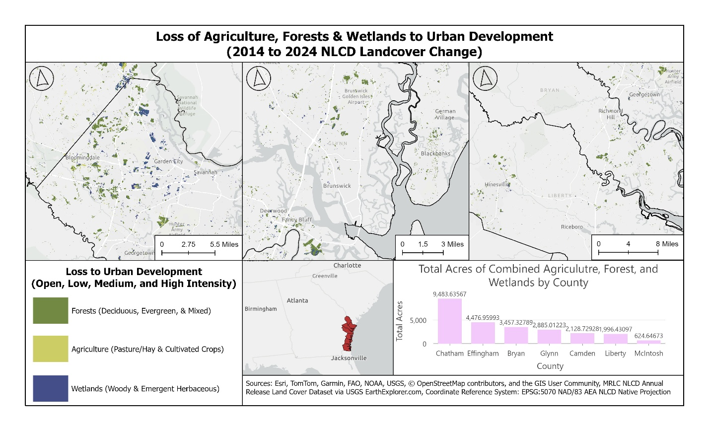
Figure 2.1:
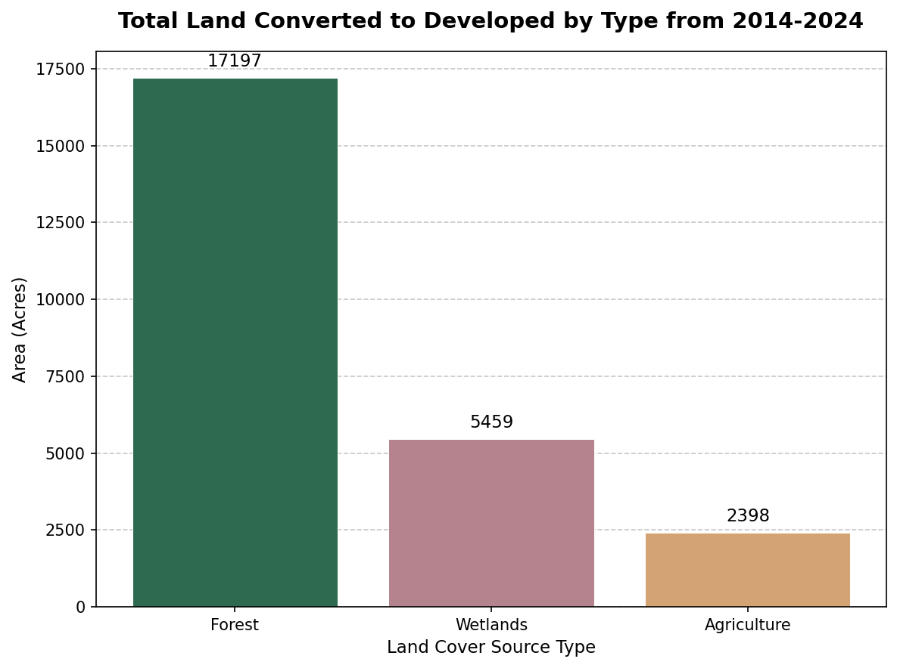
Figure 2.1:
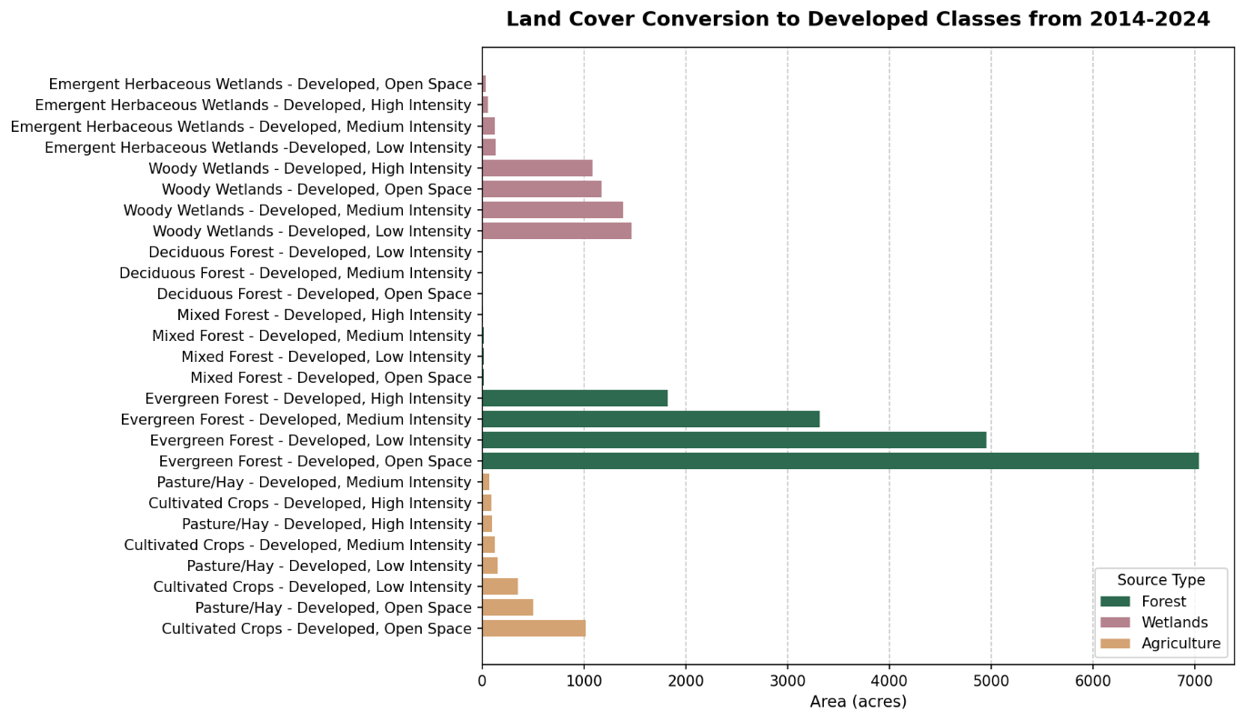
Figure 3: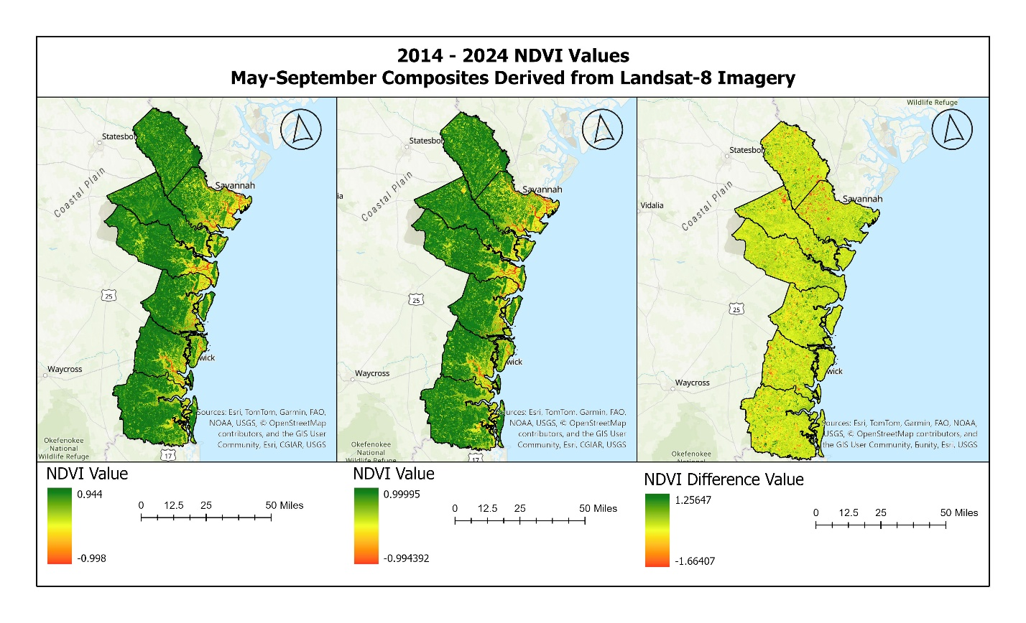
Data and Resources:
Donahue, Patrick . 2025. “Georgia Ports Poised for Future Growth in Garden City, Brunswick.” Effinghamherald.net. Effingham Herald. February 12, 2025. https://www.effinghamherald.net/local/georgia-ports-poised-for-future-growth-in-garden-city-brunswick/.
“How Deforestation Affects Urban Flooding.” 2020. Hellis Solutions Limited. January 20, 2020. https://www.hellis.biz/how-deforestation-affects-urban-flooding/.
Sacatelli, Rachael, Rutgers, Richard Lathrop, and Marjorie Kaplan. 2020. “Impacts of Climate Change on Coastal Forests in the Northeast US Photo Courtesy of Jennifer Walker.” https://doi.org/10.7282/t3-n4tn-ah53.
Twumasi, Yaw, and Edmund Merem. 2008. “Geospatial Information Systems Analysis of Regional Environmental Change along the Savannah River Basin of Georgia.” International Journal of Environmental Research and Public Health 5 (1): 54–67. https://doi.org/10.3390/ijerph5010054.
Analysis Data:
• USGS EarthExplorer.com
•NLCD Annual Release v1.1 Land Cover
• Google Earth Engine: Landsat-8 Satellite Imagery
• Google Colab using Pandas and Matplotlib Libraries for learning resources and tutorials.

